**INTRODUCTION TO COMPUTER HARDWARE**

Hardware represents the physical and tangible components of a computer, i.e. the components that can be seen and touched.

Examples of Hardware are the following −

* **Input devices** − keyboard, mouse, etc.
* **Output devices** − printer, monitor, etc.
* **Secondary storage devices** − Hard disk, CD, DVD, etc.
* **Internal components** − CPU, motherboard, RAM, etc.

For the working of the Types of Computer Hardware, it needs both hardware and software components. For every computer system, there can be several hardware components attached to the system as per the requirements. The computer hardware contains mechanical elements and electronic elements of the computer. The hardware of the computer system includes monitor, CPU, keyboard, mouse, printer, sound system, RAM, hard disk and many more. Hardware is used for taking input data from the user, store the data and display the output and execute the commands given by an individual.

Relationship between Hardware and Software

* Hardware and software are mutually dependent on each other. Both of them must work together to make a computer produce a useful output.
* Software cannot be utilized without supporting hardware.
* Hardware without a set of programs to operate upon cannot be utilized and is useless.
* To get a particular job done on the computer, relevant software should be loaded into the hardware.
* Hardware is a one-time expense.
* Software development is very expensive and is a continuing expense.
* Different software applications can be loaded on a hardware to run different jobs.
* A software acts as an interface between the user and the hardware.

MOTHERBOARD

The motherboard serves as a single platform to connect all of the parts of a computer together. It connects the CPU, memory, hard drives, optical drives, video card, sound card, and other ports and expansion cards directly or via cables. It can be considered as the backbone of a computer.

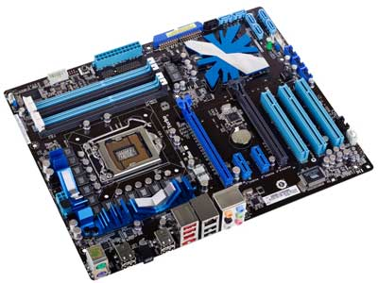

Features of Motherboard

A motherboard comes with following features −

* Motherboard varies greatly in supporting various types of components.
* Motherboard supports a single type of CPU and few types of memories.
* Video cards, hard disks, sound cards have to be compatible with the motherboard to function properly.
* Motherboards, cases, and power supplies must be compatible to work properly together.

Popular Manufacturers

Following are the popular manufacturers of the motherboard.

* Intel
* ASUS
* AOpen
* ABIT
* Biostar
* Gigabyte
* MSI

Description of Motherboard

The motherboard is mounted inside the case and is securely attached via small screws through pre-drilled holes. Motherboard contains ports to connect all of the internal components. It provides a single socket for CPU, whereas for memory, normally one or more slots are available. Motherboards provide ports to attach the floppy drive, hard drive, and optical drives via ribbon cables. Motherboard carries fans and a special port designed for power supply.

There is a peripheral card slot in front of the motherboard using which video cards, sound cards, and other expansion cards can be connected to the motherboard.

On the left side, motherboards carry a number of ports to connect the monitor, printer, mouse, keyboard, speaker, and network cables. Motherboards also provide USB ports, which allow compatible devices to be connected in plug-in/plug-out fashion. For example, pen drive, digital cameras, etc.

RANDOM ACESS MEMORY (RAM)

RAM (Random Access Memory) is the internal memory of the CPU for storing data, program, and program result. It is a read/write memory which stores data until the machine is working. As soon as the machine is switched off, data is erased.

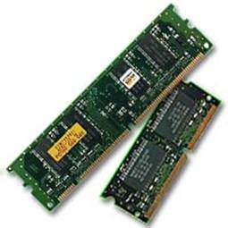

Access time in RAM is independent of the address, that is, each storage location inside the memory is as easy to reach as other locations and takes the same amount of time. Data in the RAM can be accessed randomly but it is very expensive.

RAM is volatile, i.e. data stored in it is lost when we switch off the computer or if there is a power failure. Hence, a backup Uninterruptible Power System (UPS) is often used with computers. RAM is small, both in terms of its physical size and in the amount of data it can hold.

RAM is of two types −

* Static RAM (SRAM)
* Dynamic RAM (DRAM)

## Static RAM (SRAM)

The word **static** indicates that the memory retains its contents as long as power is being supplied. However, data is lost when the power gets down due to volatile nature. SRAM chips use a matrix of 6-transistors and no capacitors. Transistors do not require power to prevent leakage, so SRAM need not be refreshed on a regular basis.

There is extra space in the matrix, hence SRAM uses more chips than DRAM for the same amount of storage space, making the manufacturing costs higher. SRAM is thus used as cache memory and has very fast access.

### Characteristic of Static RAM

* Long life
* No need to refresh
* Faster
* Used as cache memory
* Large size
* Expensive
* High power consumption

## Dynamic RAM (DRAM)

DRAM, unlike SRAM, must be continually **refreshed** in order to maintain the data. This is done by placing the memory on a refresh circuit that rewrites the data several hundred times per second. DRAM is used for most system memory as it is cheap and small. All DRAMs are made up of memory cells, which are composed of one capacitor and one transistor.

### Characteristics of Dynamic RAM

* Short data lifetime
* Needs to be refreshed continuously
* Slower as compared to SRAM
* Used as RAM
* Smaller in size
* Less expensive
* Less power consumption

DAUGHTER CARDS

A daughtercard or [daughterboard](https://www.easytechjunkie.com/what-is-a-daughterboard.htm) is a type of [circuit board](https://www.easytechjunkie.com/what-is-a-circuit-board.htm) that gets added to an existing one. Its name is appropriate for its use, since it is connected to a “[motherboard](https://www.easytechjunkie.com/what-is-a-motherboard.htm)” or “main board.” The motherboard is the primary circuit board for a device. It is usually in the device as it is shipped from the factory. A daughtercard may be added later.

Some daughtercard designs are made so that engineers can add functionality to a device without requiring a lot more room inside its housing. These kinds of items are often called riser boards or risers. Some might also call them “mezzanine boards.”



A daughtercard or daughterboard is a type of circuit board that gets added to an existing one.

Daughtercards are different from some other types of additional circuit boards that tech enthusiasts call “expansion cards.” In expansion cards, the circuit board is often plugged in through a gap in the housing of a computer or device. These expansion boards help to give a device more functionality, often for additional sound play or for better visuals on a high-tech monitor or screen.

In contrast to the way expansion boards are used, a daughtercard can be a more fundamental enhancement for a device. Adding a daughtercard often requires getting into the guts of a device. That’s why some users might hire a professional to install it. Companies that make an electronic device might offer a daughtercard as part of an essential upgrade that allows the product to be used in more various ways.With the rise of connective USB ports and other technology, it has become less necessary to upgrade devices with daughtercards or daughterboards. A lot of advanced use can be built into a wireless connection and “outsourced” to a remote server, rather than adding it physically into a desktop or laptop computer. However, some types of equipment might still get these kinds of additions as provided by the manufacturer. Computer and electronics makers choose the best ways of offering upgrades that they feel will match the needs and desires of their customer base. Since not a lot of laptop or computer users want to wrestle a daughtercard into an existing circuit board design, companies that sell to a consumer market will probably choose alternatives, or offer professional installation as a free service if they are offering a daughtercard as a way to upgrade a device.

Bus slot

Alternatively known as a **bus slot** or **expansion port**, an **expansion slot** is a connection or port inside a [computer](https://www.computerhope.com/jargon/c/computer.htm) on the [motherboard](https://www.computerhope.com/jargon/m/mothboar.htm) or [riser card](https://www.computerhope.com/jargon/r/risecard.htm). It provides an installation point for a hardware expansion card to be connected. For example, if you wanted to install a new video card in the computer, you'd purchase a video expansion card and install that card into the compatible expansion slot.

## Computer expansion slots

Below is a listing of expansion slots commonly found in a computer and the devices associated with those slots. Clicking any of the links below provide you with additional details.

* [AGP](https://www.computerhope.com/jargon/a/agp.htm) - [Video card](https://www.computerhope.com/jargon/v/video-card.htm).
* [AMR](https://www.computerhope.com/jargon/a/amr.htm) - [Modem](https://www.computerhope.com/jargon/m/modem.htm), [sound card](https://www.computerhope.com/jargon/s/souncard.htm).
* [CNR](https://www.computerhope.com/jargon/c/cnr.htm) - Modem, [network card](https://www.computerhope.com/jargon/n/nic.htm), sound card.
* [EISA](https://www.computerhope.com/jargon/e/eisa.htm) - [SCSI](https://www.computerhope.com/jargon/s/scsi.htm), network card, video card.
* [ISA](https://www.computerhope.com/jargon/i/isa.htm) - Network card, sound card, video card.
* [PCI](https://www.computerhope.com/jargon/p/pci.htm) - Network card, SCSI, sound card, video card.
* [PCI Express](https://www.computerhope.com/jargon/p/pciexpre.htm) - Video card, modem, sound card, network card.
* [VESA](https://www.computerhope.com/jargon/v/vesa.htm) - Video card.

Many of the expansion card slots above are obsolete. You're most likely only going to encounter AGP, PCI, and PCI Express when working with computers today. The picture below is an example of what expansion slots may look like on a motherboard. In this picture, there are three different types of expansion slots: PCI Express, PCI, and AGP.

[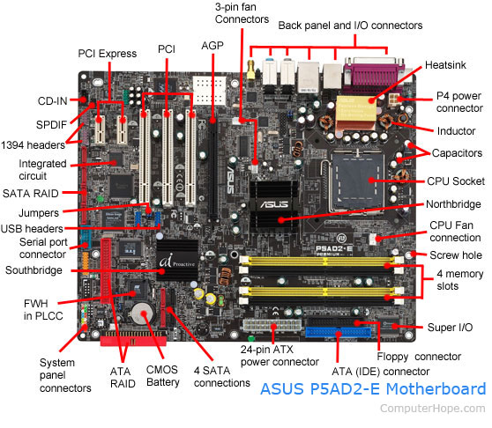](https://www.computerhope.com/cdn/bigmb.jpg)

# Switched-Mode Power Supply (SMPS)

## What Does Switched-Mode Power Supply (SMPS) Mean?

A switched-mode power supply (SMPS) is an electronic circuit that converts power using switching devices that are turned on and off at high frequencies, and storage components such as inductors or capacitors to supply power when the switching device is in its non-conduction state.

Switching power supplies have high efficiency and are widely used in a variety of electronic equipment, including computers and other sensitive equipment requiring stable and efficient power supply.

A switched-mode power supply is also known as a switch-mode power supply or switching-mode power supply.

## Techopedia Explains Switched-Mode Power Supply (SMPS)

Switched-mode power supplies are classified according to the type of input and output voltages. The four major categories are:

* AC to DC
* DC to DC
* DC to AC
* AC to AC

A basic isolated AC to DC switched-mode power supply consists of:

* Input rectifier and filter
* Inverter consisting of switching devices such as MOSFETs
* Transformer
* Output rectifier and filter
* Feedback and control circuit

The input DC supply from a rectifier or battery is fed to the inverter where it is turned on and off at high frequencies of between 20 KHz and 200 KHz by the switching MOSFET or power transistors. The high-frequency voltage pulses from the inverter are fed to the transformer primary winding, and the secondary AC output is rectified and smoothed to produce the required DC voltages. A feedback circuit monitors the output voltage and instructs the control circuit to adjust the duty cycle to maintain the output at the desired level.

There are different circuit configurations known as topologies, each having unique characteristics, advantages and modes of operation, which determines how the input power is transferred to the output.

Most of the commonly used topologies such as flyback, push-pull, half bridge and full bridge, consist of a transformer to provide isolation, voltage scaling, and multiple output voltages. The non-isolated configurations do not have a transformer and the power conversion is provided by the inductive energy transfer.

Advantages of switched-mode power supplies:

* Higher efficiency of 68% to 90%
* Regulated and reliable outputs regardless of variations in input supply voltage
* Small size and lighter
* Flexible technology
* High power density

Disadvantages:

* Generates electromagnetic interference
* Complex circuit design
* Expensive compared to linear supplies

Switched-mode power supplies are used to power a wide variety of equipment such as computers, sensitive electronics, battery-operated devices and other equipment requiring high efficiency.

## Internal Storage Devices

Some storage devices are classed as 'internal' which means they are inside the computer case.

Most computers have some form of internal storage. The most common type of internal storage is the hard disk.

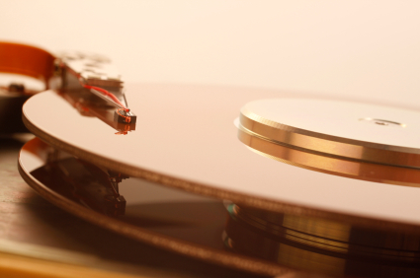

At the most basic level, internal storage is needed to hold the operating system so that the computer is able to access the input and output devices.

It will also be used to store the applications software that you use and more than likely, the original copies of your data files.

Internal storage allows the data and applications to be loaded very rapidly into memory, ready for use. The data can be accessed much faster than data which is stored on an external storage device. This is because internal storage devices are connected directly to the motherboard and its data bus whereas external devices are connected through a hardware interface such as USB, which means they are considerably slower to access.

Internal storage also means that if the computer is moved around, it will still retain its most commonly used data.

The main disadvantage of internal storage is that when the hard disk fails (and it will), all the data and applications may be lost.

This can be avoided to some extent by using more than one hard disk within the machine. Each hard disk has a copy of all the data, so if one fails the other can carry on. This is called a RAID array. An alternative is to use external drives for backup

# Computer Ports

A port is a connection or a jack provided on a computer to connect external or peripheral devices to the computer, for example, you will need a port on your device to connect a keyboard, mouse, pen-drives, etc. So, it acts as an interface or a point of attachment between [computer](https://www.javatpoint.com/computer-fundamentals-tutorial) and external devices. It is also called a communication port, as it is the point where you plug in a peripheral device to allow data transfer or communication between the device and computer. Generally, they are four to six in number and present on the back or sides of the computer.

Based on the type of protocol used for communication, computer ports can be of two types: Serial Ports and Parallel Ports.

## Serial Port:

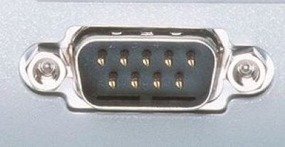

This type of ports provides an interface to connect to peripheral devices using a serial protocol. In this port, the rate of transmission of data is one bit at a time through a single communication line. For example, D-Subminiature or D-sub connector is a commonly used serial port, which carries RS-232 signals.

## Parallel Port:

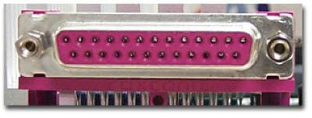

As the name suggests, a parallel port is an interface that allows communication or data transfer between a computer and a device in a parallel manner through more than one communication line. For example, a printer port is a parallel port.

Examples of Computer Ports:

### PS/2:

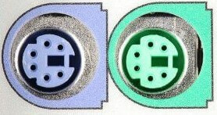

As the name suggests, it was introduced with IBM's Personal Systems/2 series of computers. These connectors are colour coded, e.g., green was for mouse, and purple was for the keyboard. Besides this, it is a DIN connector with six pins. At present, it is superseded by USB ports.

### 2) VGA Port:

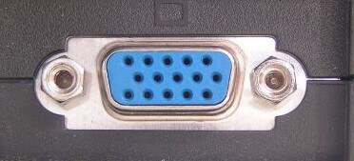

This port is commonly found in computers, projectors, and high definition TVs. It is a D-sub connector called DR-15 as it has 15 pins, which are arranged in 3 rows with five pins in each row. It was most often used to connect [CPU](https://www.javatpoint.com/cpu-full-form) with CRT monitors. Still, most of the [LCD](https://www.javatpoint.com/lcd-full-form) and [LED](https://www.javatpoint.com/led-full-form) monitors come with [VGA](https://www.javatpoint.com/vga-full-form) ports. However, these ports don't assure high picture quality as VGA can carry only analogue video signals up to a resolution of 648X480.

As the demand and emphasis on video quality kept growing, the VGA ports were gradually replaced by more advanced ports that can assure high video quality such as [HDMI](https://www.javatpoint.com/hdmi-full-form) and Display Ports.

### 3) Digital Video Interface (DVI):

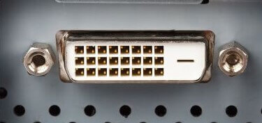

It is another interface between a [CPU](https://www.javatpoint.com/central-processing-unit) and a monitor. It is a high-speed interface that is developed to transmit the lossless digital video signals and to replace analogue digital video signal transmission through VGA technology.

The DVI interface can be of three types based on the signals transmitted by it: DVI-I, DVI-D, and DVI-A. The DVI-I supports combined digital and analogue signals, whereas DVI-A supports only analogue signals, and DVI-D supports only digital signals.

**Mini-DVI:** As the name suggests, it is smaller than a commonly used DVI port. It is a 32 pin port developed by Apple as a substitute to Mini-VGA port. It can transmit various types of signals such as S-Video, VGA, and composite signals using respective adapters.

### 4) Display Port:

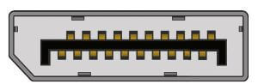

This interface allows transmitting a video and audio from a device to a display screen. It is an advanced display technology that is developed as a substitute for older interfaces such as DVI and VGA. A display port can be seen on laptops, desktops computers, tablets, monitors, etc. It has a 20-pin connector and offers a better resolution than DVI port.

### 5) RCA Connector:

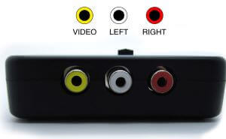

It is designed to accept composite video and stereo signals transmitted by three cables called RCA cable. A RAC cable has three color-coded plugs that are connected to the three corresponding coloured jacks of an RCA connector. Each of the coloured jack is ringed with metal. The red jack supports the right stereo channel, and the white one supports the left stereo channel, while the yellow is used for composite video.

### 6) Component Video:

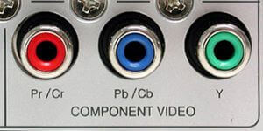

This interface allows splitting video signals into three channels. The component video generally has three color-coded slots; Red, Blue, and Green. Each slot receives and then transmits a particular component of the video signal. It offers high-quality videos than composite video and can carry both analogue and digital video signals.

### 7) HDMI port:

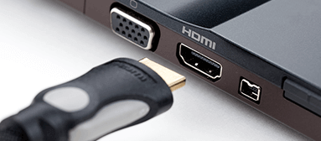

HDMI (High Definition Media Interface) is a digital interface developed to connect high definition devices such as digital cameras, gaming consoles, etc., to computers and TVs with HDMI ports. Besides this, it can carry uncompressed video and uncompressed or compressed audio signals. The advanced version of HDMI, such as 2.0, can transfer video signals of up to a resolution of 4096x2160.

### 8) USB:

[USB](https://www.javatpoint.com/usb-full-form) (Universal Serial Bus) port is very versatile in use; It can be used for various purposes, such as to transfer data, to connect peripheral devices, and even as an interface for charging devices such as smartphones, digital cameras, etc. Today, it has replaced PS/2 connectors, game ports, serial and parallel ports, etc.

### Types of USB ports:

**USB Type A:**

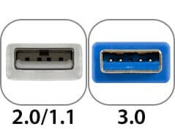

It is a four-pin connector and has many versions that include USB 1.1, USB 2.0 and USB 3.0, and USB 3.1. Version 3.0 is a common standard that supports a data transfer rate of upto 400 [MBps](https://www.javatpoint.com/mbps-full-form). Version 3.1 allows a data rate of upto 10 Gbps.

**USB Type C:**

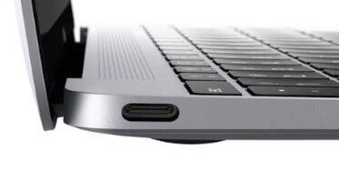

It is the latest design of the USB that comes with 24 pins and can handle a current of 3A. As it can handle high current, it is also used in devices for fast charging. This port was developed by the USB Implementers Forum (USB-IF). One of the distinguishing features of this port is that it has no up or down orientation, which means you don't need to flip the male connecter over to plug it in the USB port. For example, a USB-C plug is symmetrical, so that it can be inserted or plugged in either way.

### 9) RJ-45:

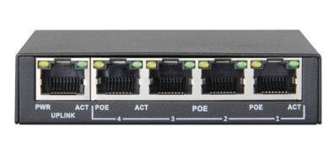

It is an Ethernet style network port found on the computer and other devices such as routers, switches, etc. This port allows your computer to interact or communicate with other computers and networking devices where Ethernet networking is required.

Its full form is Registered Jack 45. It is also known as Ethernet port, network jack, or RJ45 jack. It has eight pins; accordingly, the RJ45 cable comprises eight separate wires of different colours. Besides this, it looks like a telephone jack; however, it is slightly wider than that.

### 10) RJ11:

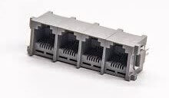

It is also a registered jack, which is often used as an interface for modem, ADSL, and telephone and for terminating the telephone wires. Although it looks like RJ45, it is different from that as it is smaller and has only six pins; it is a 6P4C connector that shows it has six pins with four contacts. This port is mainly used to connect to dial-up modems and is also known as a phone connector, modem port, phone jack, etc.

### 11) 3.5 mm Audio Jack:

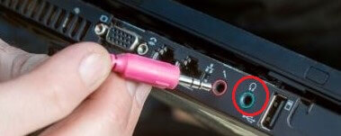

It is a small round connector, port, or an audio jack commonly found on laptops, computers, phones, etc. It is designed to connect to wired headphones and speakers. In other words, it accepts a pin-shaped plug from a headphone, earphone, etc. The measurement "3.5 mm" denotes the diameter of the connector.

SPECIFICATION OF DESKTOP AND SERVER CLASS COMPUTERS

Here is a sample desktop computer specification if you are searching for a good desktop computer to buy. I have listed the most component features you should check when you buy desktop computer.

Actually, the intended usage of a computer should be your first step to answer. Why are you going to buy? What are you going to do with it? I say this because you don’t have to buy a high-end pc for tasks such as word processing, spreadsheet, web browsing or e-mail.

If you do have enough budgets, go for it. For the future it will serve you well for graphical and design works too.

This is a typical desktop computer specification, this doesn’t mean you should buy this computer. It is just a guide to help you.

|  |  |
| --- | --- |
| Component | Specification |
| Processor: | 10th or 11th Gen Intel Core i5, i7 or i9 Processor, or Apple M1 Processor (CPU) |
| Operating System: | Microsoft Windows 10 Home, Pro, Enterprise or Education version *or* macOS 10.15.X “Catalina” or 11.X “Big Sur.” |
| Memory (RAM): | 8-16 GB of RAM |
| Storage: | 240 GB solid state drive, or larger. |
| Video/Graphics: | Integrated or Discrete graphics processor capable of  1440 X 900 resolution, or better (1920 X 1080 *or* 1200 ideal). |
| Monitor: | for notebook: 13″ – 17″ display for desktop: 19″ – 27″ widescreen flat-panel display |
| Mouse: | Built-in or external trackpad, wireless and/or USB, 2-button, optical mouse |
| Sound: | Sound card or built-in audio, and speakers |
| Headphones: | Headphones or Earbuds, with Built-in Microphone |
| Webcam: | Either external USB device or built-in |
| Network: | 802.11ac Wi-Fi capability. |

*Intel i5 & i7*

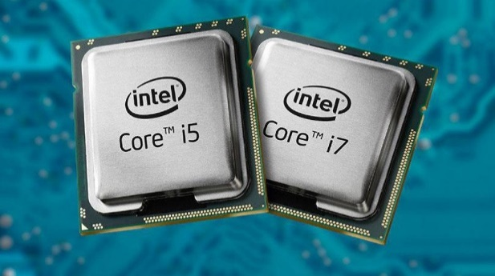

*Ryzen*

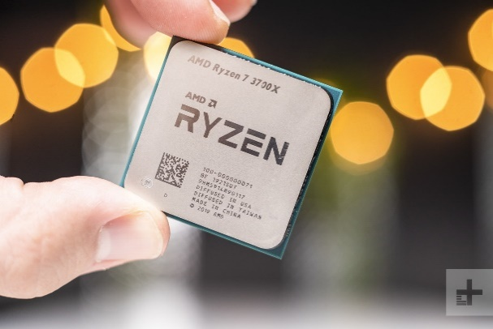

© www.teach-ict.com